**BYOD Application User Guide**

This document explains, how the user can tag and train their images using the BYOD app.

Here are the steps to follow,

**Step 1:**

Upload the Images in the sitecore media library, as shown below,

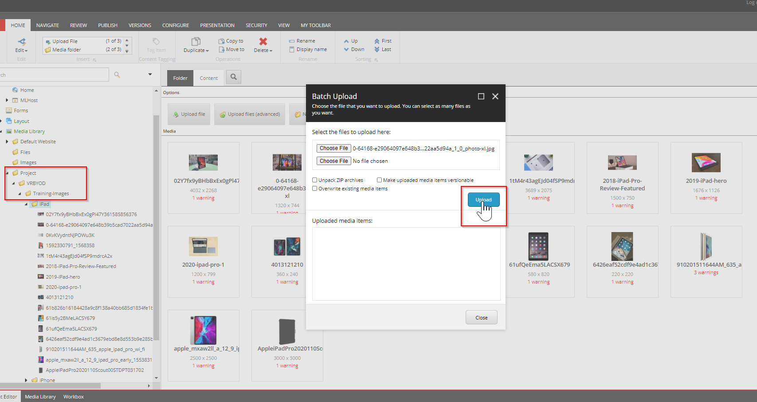

Note: As it is a new idea we are implementing, so currently we have mapped the folder called Training Images, so the User have to upload their images under the Training folder.in future the idea can be expand with the dynamic folder.

**Step 2:**

In the sitecore Desktop view, Use the “Image Visual Tagging” option to redirect to the Vott app page, here the user can tag the images , based on the category ,

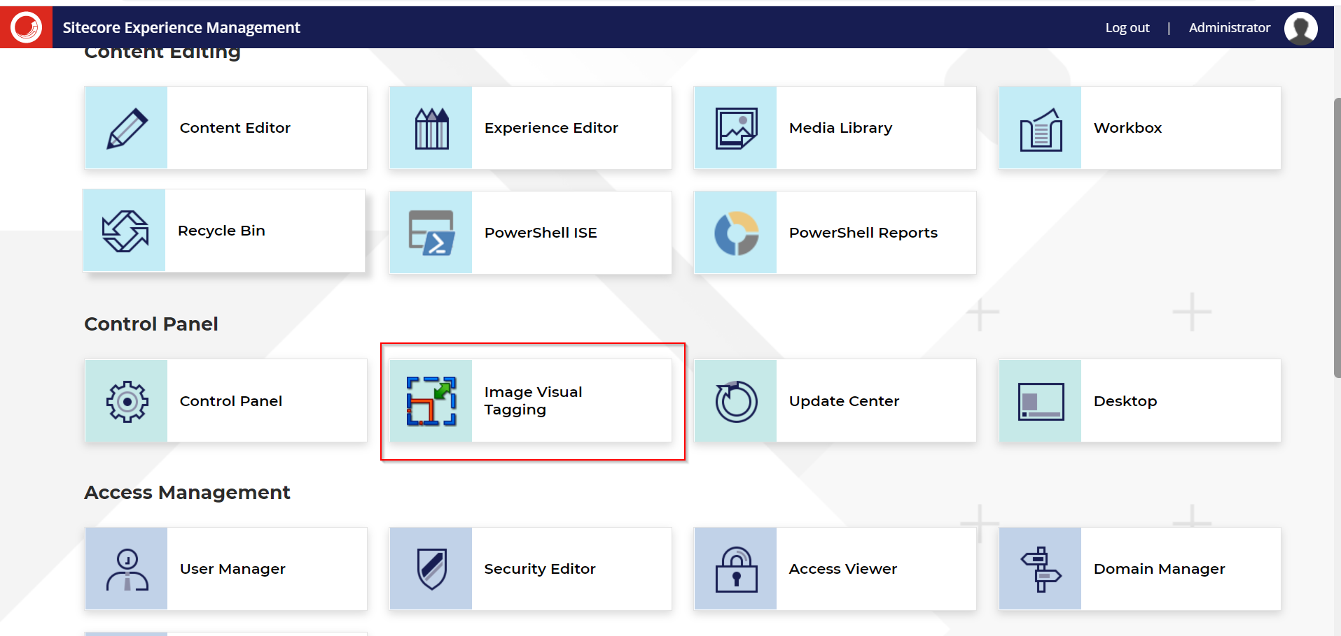

The user can select the area in the image and tag with the respective category.

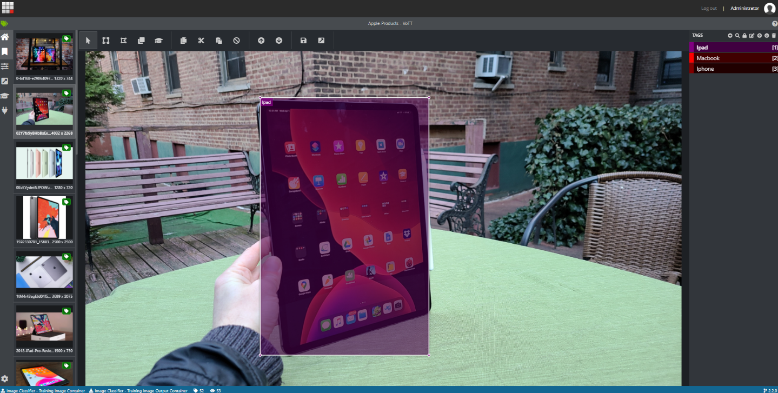

Once done, click on the button Export to train the image on our custom App,

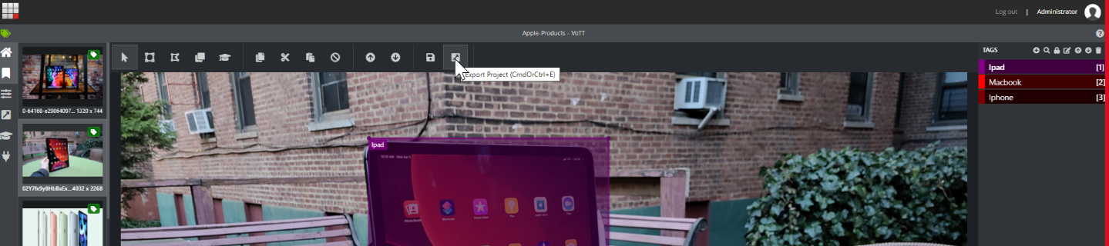

**Step 3: Train Using RenderingHost**

After Exporting the image from sitecore, move to our rendering host site to train the image

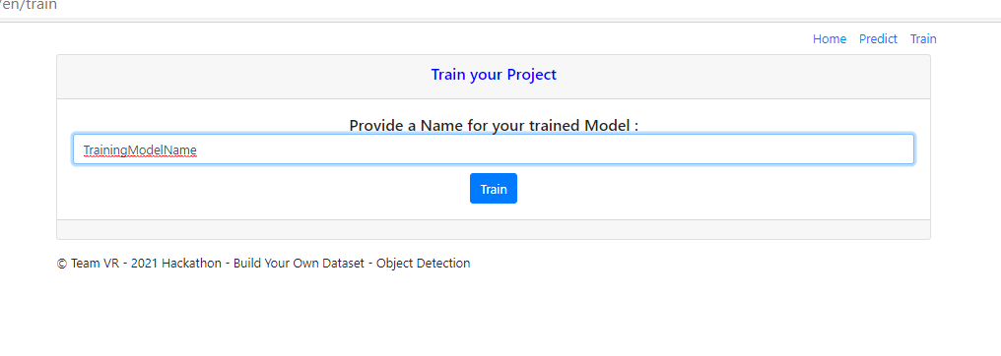

**Step 4: Predict Image**

Click on the Predict image menu, and the end user can upload the image to find out the elements in the picture.

